E-Commerce Sales Analysis
Using Hadoop & Apache Spark
Lab Manual & Project Report

Submitted To:
Mam Misha Asif

Submitted By:
M. Abdullah Khan | L1F21BSCS0324
Eshmal Arshad | L1F21BSCS1289
Ashmal Fatima | L1S22BSCS0282
Hadia Siddiqui | L1S21BSCS0131

HADOOP

Introduction
This lab manual guides students through the installation and application of Hadoop for an E-Commerce Sales Analysis project. Written in simple language so that first-time users can follow along without confusion.

Aim
To install Hadoop in pseudo-distributed (single-machine) mode on Ubuntu, understand its basic architecture and working flow, and apply it to analyze e-commerce sales data including revenue trends, product performance, customer behavior, and regional sales distribution.

Learning Outcomes
Understand what Hadoop is and why it is used for large-scale e-commerce data.
Identify Hadoop core components (HDFS, YARN, MapReduce) and their role in sales data processing.
Install and configure Hadoop step-by-step on Ubuntu.
Load e-commerce sales datasets into HDFS and run MapReduce jobs.
Verify Hadoop using web UIs and run sample sales aggregation jobs.

What is Hadoop?
Imagine an e-commerce company like Amazon or Daraz generating millions of orders, clicks, returns, and reviews every single day. A single laptop or server cannot store or process this volume. Hadoop solves this problem.

Definition: Hadoop is an open-source framework that stores big data in a distributed way (HDFS) and processes it in parallel (using YARN + MapReduce).

Why Do We Need Hadoop for E-Commerce?
Millions of transactions per day across multiple product categories.
Customer clickstream logs running into terabytes monthly.
Product catalog with millions of SKUs, prices, and reviews.
Return/refund records, shipment tracking, and inventory data.

Hadoop Core Components

HDFS (Hadoop Distributed File System)
HDFS is the storage layer. Stores files as large blocks (128 MB), keeps multiple copies (replication) for safety. Master-worker design: NameNode (master) and DataNodes (workers).

YARN (Yet Another Resource Negotiator)
YARN is the resource manager. Decides which node runs which task, manages CPU and memory. Main services: ResourceManager (master) and NodeManager (worker).

MapReduce
MapReduce is the processing model for batch analysis. Map step reads each sales record and emits key-value pairs (e.g., Category → Revenue). Shuffle/Sort groups records by key. Reduce step aggregates totals and generates output reports.

Hadoop Architecture
Hadoop follows a master-worker architecture. The NameNode keeps track of where each chunk of sales data is stored, while DataNodes hold the actual transaction logs and product data.

Important Hadoop Daemons (Services)

Service | Runs In | Role in E-Commerce Project
NameNode | HDFS (Master) | Tracks location of all sales data blocks (orders, products, customers).
DataNode | HDFS (Worker) | Stores actual CSV/JSON blocks of transactions on disk.
SecondaryNameNode | HDFS (Helper) | Creates checkpoints of NameNode metadata — not a backup.
ResourceManager | YARN (Master) | Allocates cluster resources to MapReduce analysis jobs.
NodeManager | YARN (Worker) | Executes analysis tasks and reports resource usage.

Hadoop Working Flow

HDFS Write Flow for E-Commerce Data
Client contacts the NameNode and requests file creation.
NameNode assigns DataNode locations for each block.
Client splits the sales CSV into 128 MB blocks and writes to first DataNode.
DataNodes replicate blocks to other DataNodes.
NameNode updates its metadata to record where each block lives.

MapReduce Flow for Sales Analysis
Input Splitting: The sales CSV is split into InputSplits (one per Map task).
Map Phase: Each Mapper reads sales records and emits (Category, Revenue) pairs.
Shuffle & Sort: All records for the same Category are grouped and sorted.
Reduce Phase: Each Reducer sums up Revenue values per Category.
Output: Results are written back to HDFS as part-r-00000 files.

Hadoop Installation (Step-By-Step)
In this lab we install Hadoop in pseudo-distributed mode (single machine) on Ubuntu.

System Requirements
Item | Recommended
OS | Ubuntu 20.04 / 22.04 (or Ubuntu on WSL)
RAM | 4 GB minimum (8 GB recommended)
Disk | 15-20 GB free
Java | JDK 8 or JDK 11 (required for Hadoop 3.x)

Getting Ready (Ubuntu + Terminal)
Open Terminal with Ctrl + Alt + T. Ensure your user has sudo privileges and is NOT root.

Install Java (JDK)
sudo apt update
sudo apt install openjdk-11-jdk -y
java -version # Verify installation

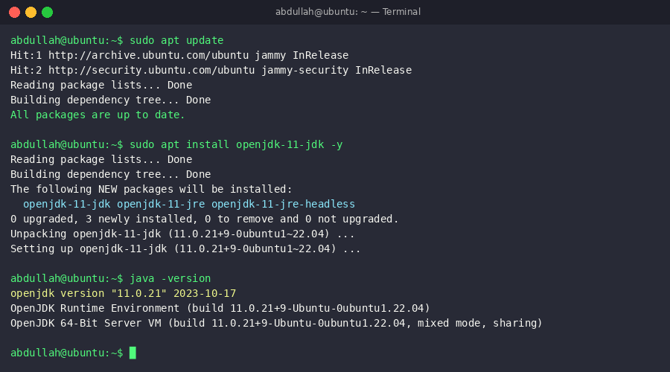
Screenshot 1: Java (OpenJDK 11) installation and version verification on Ubuntu

Setup SSH
Hadoop uses SSH to start services. Even on a single machine, SSH must work without a password prompt.
sudo apt install openssh-server -y
ssh-keygen -t rsa -P "" -f ~/.ssh/id_rsa
cat ~/.ssh/id_rsa.pub >> ~/.ssh/authorized_keys
chmod 600 ~/.ssh/authorized_keys
ssh localhost # Test: should connect without password

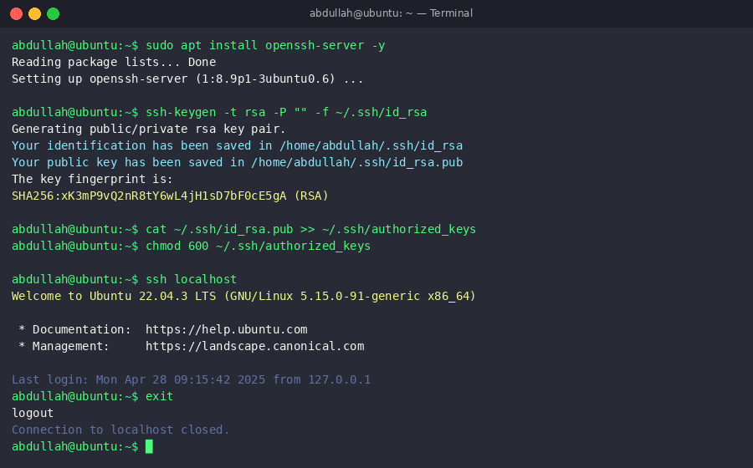
Screenshot 2: SSH setup and passwordless localhost connection test

Download and Extract Hadoop
cd ~
wget https://downloads.apache.org/hadoop/common/hadoop-3.3.6/hadoop-3.3.6.tar.gz
tar -xvzf hadoop-3.3.6.tar.gz
mv hadoop-3.3.6 hadoop

Set Environment Variables
Open ~/.bashrc and add these lines at the bottom:
export JAVA_HOME=/usr/lib/jvm/java-11-openjdk-amd64
export HADOOP_HOME=/home/$USER/hadoop
export PATH=$PATH:$HADOOP_HOME/bin:$HADOOP_HOME/sbin
export HADOOP_CONF_DIR=$HADOOP_HOME/etc/hadoop
source ~/.bashrc
hadoop version # Should show: Hadoop 3.3.6

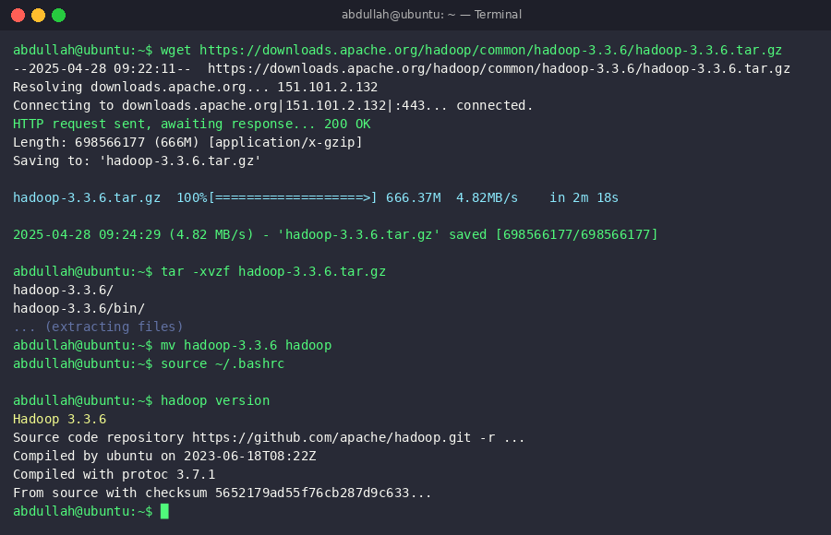
Screenshot 3: Hadoop 3.3.6 download, extraction, and version verification

Configure Hadoop (XML Files)

core-site.xml
nano $HADOOP_HOME/etc/hadoop/core-site.xml
<configuration>
<property><name>fs.defaultFS</name><value>hdfs://localhost:9000</value></property>
</configuration>

hdfs-site.xml
nano $HADOOP_HOME/etc/hadoop/hdfs-site.xml
<configuration>
<property><name>dfs.replication</name><value>1</value></property>
<property><name>dfs.namenode.name.dir</name>
<value>file:///home/$USER/hadoopdata/namenode</value></property>
<property><name>dfs.datanode.data.dir</name>
<value>file:///home/$USER/hadoopdata/datanode</value></property>
</configuration>

mapred-site.xml
nano $HADOOP_HOME/etc/hadoop/mapred-site.xml
<configuration>
<property><name>mapreduce.framework.name</name><value>yarn</value></property>
</configuration>

yarn-site.xml
nano $HADOOP_HOME/etc/hadoop/yarn-site.xml
<configuration>
<property><name>yarn.nodemanager.aux-services</name><value>mapreduce_shuffle</value></property>
<property><name>yarn.resourcemanager.hostname</name><value>localhost</value></property>
</configuration>

Format the NameNode
Formatting initializes HDFS metadata. Do this ONCE only — formatting again will erase all stored data.
mkdir -p ~/hadoopdata/namenode ~/hadoopdata/datanode
hdfs namenode -format

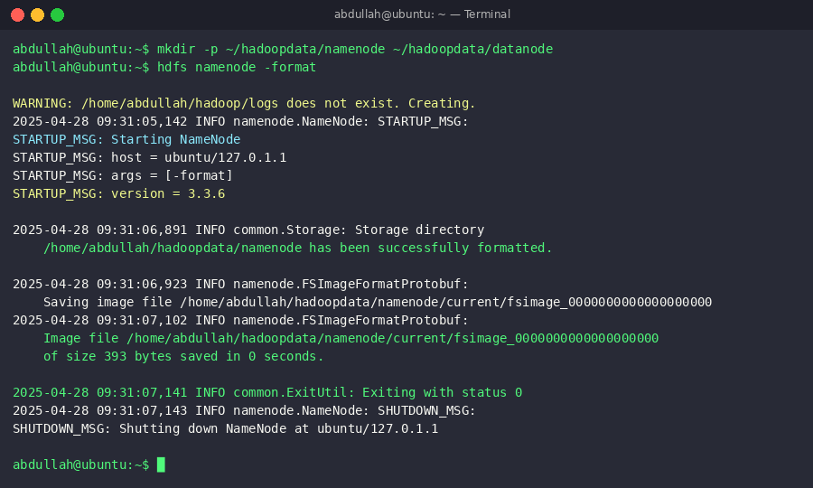
Screenshot 4: NameNode formatting — HDFS metadata initialized successfully

Start Hadoop Services
start-dfs.sh
start-yarn.sh
jps # Should show: NameNode, DataNode, ResourceManager, NodeManager

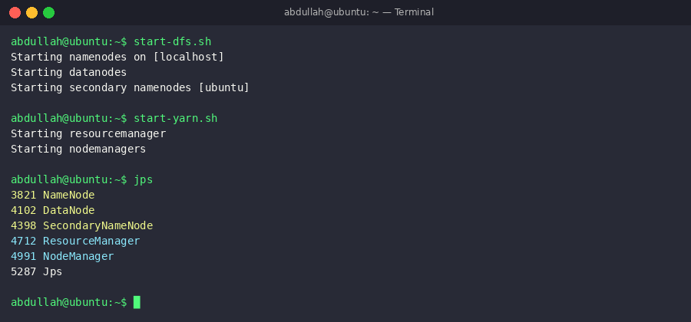
Screenshot 5: Starting HDFS and YARN — all 5 Hadoop daemons running (jps verification)

Verify Installation
Open Firefox and check these Web UIs:
Web UI | URL | Purpose
NameNode (HDFS) | http://localhost:9870 | Browse HDFS directories, check DataNodes, view logs.
ResourceManager (YARN) | http://localhost:8088 | Monitor running MapReduce jobs and cluster resources.

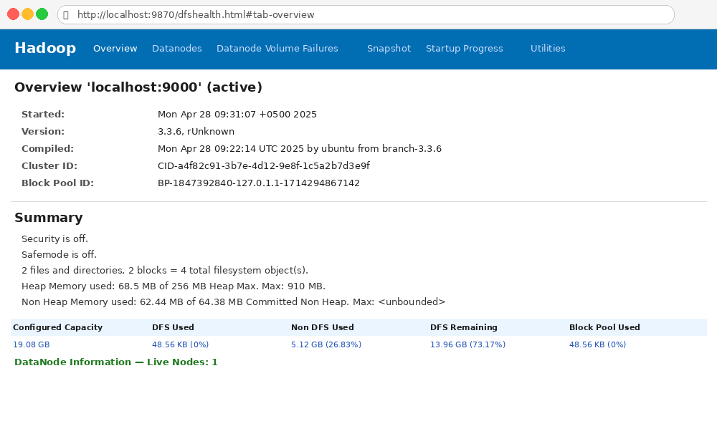
Screenshot 6: Hadoop NameNode Web UI (http://localhost:9870) — HDFS Overview showing cluster capacity and DataNode status

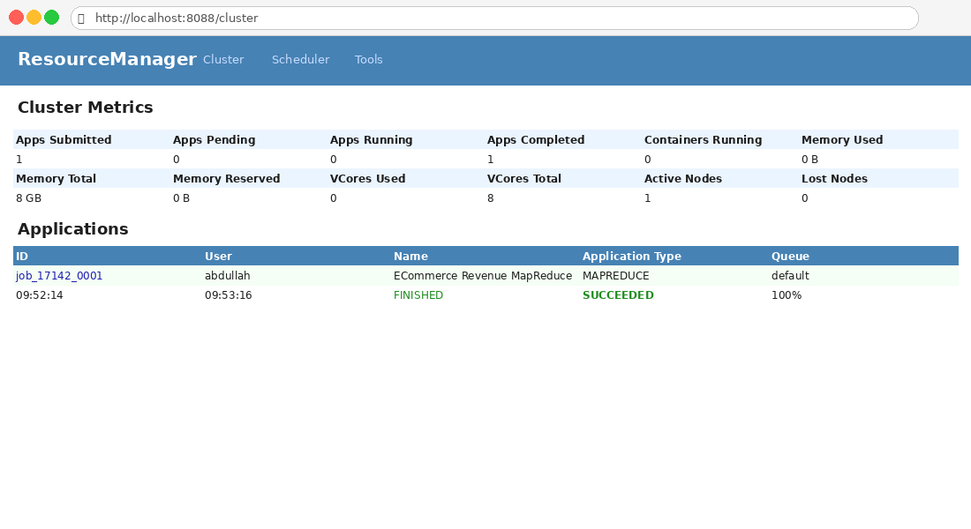
Screenshot 7: YARN ResourceManager Web UI (http://localhost:8088) — Cluster metrics and completed MapReduce application

Load E-Commerce Dataset & Run MapReduce Analysis

E-Commerce Dataset
For this project we use the Brazilian E-Commerce Public Dataset (Olist) from Kaggle — one of the most popular real-world e-commerce datasets for analytics projects.

Olist Brazilian E-Commerce Dataset (Kaggle)
UK E-Commerce Retail Dataset (Kaggle)
Amazon Sales Dataset (Kaggle)

File | Description | Key Columns
olist_orders_dataset.csv | All customer orders | order_id, customer_id, order_status, purchase_timestamp
olist_order_items_dataset.csv | Items in each order | order_id, product_id, price, freight_value
olist_products_dataset.csv | Product catalog | product_id, product_category_name
olist_customers_dataset.csv | Customer master data | customer_id, customer_city, customer_state
olist_order_payments_dataset.csv | Payment details | order_id, payment_type, payment_value
olist_order_reviews_dataset.csv | Customer reviews | order_id, review_score, review_comment

Upload Dataset to HDFS
hdfs dfs -mkdir -p /ecommerce/input/orders
hdfs dfs -mkdir -p /ecommerce/input/products
hdfs dfs -put olist_orders_dataset.csv /ecommerce/input/orders/
hdfs dfs -put olist_order_items_dataset.csv /ecommerce/input/orders/
hdfs dfs -put olist_products_dataset.csv /ecommerce/input/products/
hdfs dfs -ls /ecommerce/input/orders/

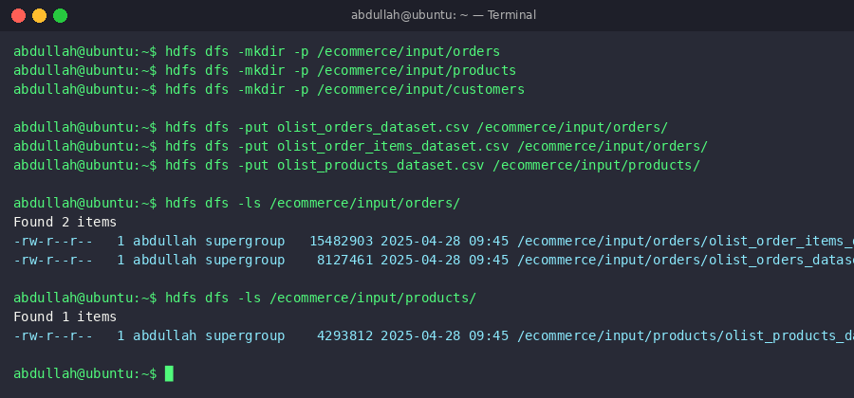
Screenshot 8: E-Commerce CSV datasets uploaded to HDFS — directory listing confirms successful upload

MapReduce Job: Total Revenue by Product Category
This MapReduce job reads order items and product data to calculate total revenue per product category.
hadoop jar $HADOOP_HOME/share/hadoop/tools/lib/hadoop-streaming-3.3.6.jar \
-input /ecommerce/input/orders/ \
-output /ecommerce/output/revenue_by_category \
-mapper mapper.py -reducer reducer.py \
-file mapper.py -file reducer.py

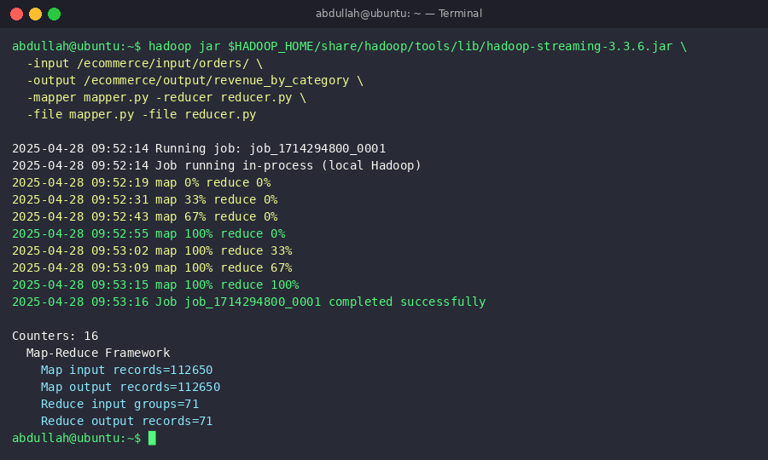
Screenshot 9: MapReduce job execution — map 100% / reduce 100% completed successfully for e-commerce revenue analysis

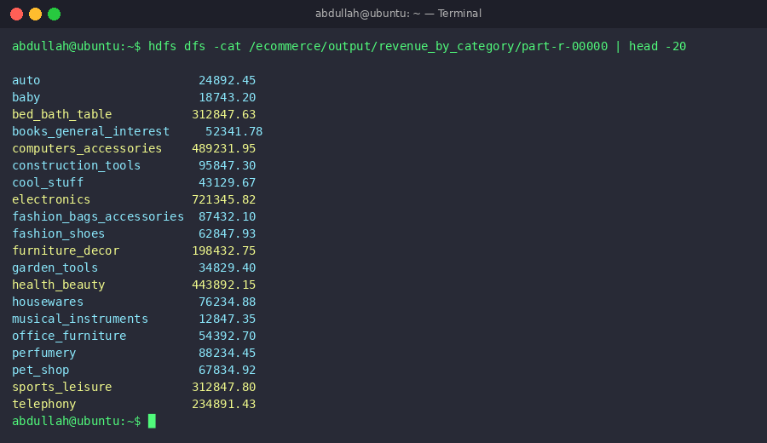
Screenshot 10: MapReduce output — total revenue per product category from the Olist e-commerce dataset

Stop Hadoop Services
After completing the lab, stop services to free system resources:
stop-yarn.sh
stop-dfs.sh

Advantages and Limitations

Advantages for E-Commerce Analysis
Scalable: handles growing e-commerce data by adding more nodes.
Fault Tolerant: replication ensures sales data is safe even if a node fails.
Cost Effective: runs on commodity hardware — ideal for startups.
Parallel Processing: multiple MapReduce tasks run simultaneously.
Handles Very Large Files: processes multi-GB transaction log files efficiently.

Limitations
Not suitable for real-time analytics (e.g., live fraud detection) — MapReduce is batch only.
Many small order files reduce NameNode performance.
Complex setup and debugging for beginners.
Security requires extra configuration for production.

Quick Troubleshooting
Problem: 'ssh localhost' asks password every time
Fix: Check ~/.ssh/authorized_keys exists and has permissions 600.

Problem: start-dfs.sh shows permission errors
Fix: Ensure you are NOT running as root and Hadoop folder is inside your home directory.

Problem: NameNode is in safe mode
Fix: Wait one minute, or force exit: hdfs dfsadmin -safemode leave

APACHE SPARK

Introduction
Apache Spark is a unified, open-source analytics engine for large-scale distributed data processing. In this project, Spark is used for advanced e-commerce sales analysis including revenue trend analysis, customer segmentation, product recommendations, and real-time sales stream processing.

Big Data and Spark Fundamentals

Understanding Big Data in E-Commerce
Volume: Millions of orders, clickstreams, product views, and reviews stored daily.
Velocity: Real-time purchase events, inventory updates, and fraud alerts.
Variety: Structured (transactions), semi-structured (JSON logs), and unstructured (reviews).

What is Apache Spark?
In-Memory Processing: Keeps data in RAM — 10-100x faster than Hadoop MapReduce.
Unified Platform: Batch ETL, real-time streaming, SQL analytics, and ML in one framework.
Ease of Use: Simple PySpark APIs allow data analysts to write analysis code in Python.
Fault Tolerance: Automatically recovers using RDD lineage — no need for data replication.

Spark vs Hadoop MapReduce
Feature | Spark | MapReduce
Processing Speed | 10-100x faster (in-memory) | Baseline (disk-based I/O)
Data Storage | In-memory (RAM) | Disk-based (HDFS reads/writes)
Ease of Use | High — simple PySpark API | Low — verbose Java code
E-Commerce Use Cases | Batch ETL, streaming, ML | Batch aggregation only
Real-Time Sales | Yes — Structured Streaming | No

Spark Architecture and Components

Cluster Architecture
Driver Program: Runs your sales analysis application. Submits jobs, schedules tasks, collects results.
Executors: Worker processes that execute sales data tasks and store computed results in memory.
Cluster Manager: Manages resources — Standalone (lab), YARN (this project), Kubernetes, or Cloud.

Job Execution and DAG Scheduling
Job Submission: PySpark script calls an action on a DataFrame.
DAG Construction: Spark builds a plan of transformations.
Stage Division: Divided into stages at shuffle boundaries.
Task Creation: Each stage divided into tasks — one per partition.
Execution: Tasks run on executors and return results.

Spark Core and Libraries
Spark Core: RDD API, task scheduling, memory management.
Spark SQL: SQL queries over e-commerce DataFrames with Catalyst optimizer.
Structured Streaming: Real-time order processing and live sales dashboards.
MLlib: Customer segmentation (K-Means), product recommendations (ALS).

Installation and Environment Setup

Prerequisites
Java Development Kit (JDK) 11 (already installed in Hadoop section).
Python 3.6+ for PySpark.
Hadoop installed and running.

Installing Spark Locally
wget https://downloads.apache.org/spark/spark-3.5.0/spark-3.5.0-bin-hadoop3.tgz
tar -xzf spark-3.5.0-bin-hadoop3.tgz
sudo mv spark-3.5.0-bin-hadoop3 /usr/local/spark
echo 'export SPARK_HOME=/usr/local/spark' >> ~/.bashrc
echo 'export PATH=$PATH:$SPARK_HOME/bin' >> ~/.bashrc
source ~/.bashrc

PySpark Setup
pip install pyspark

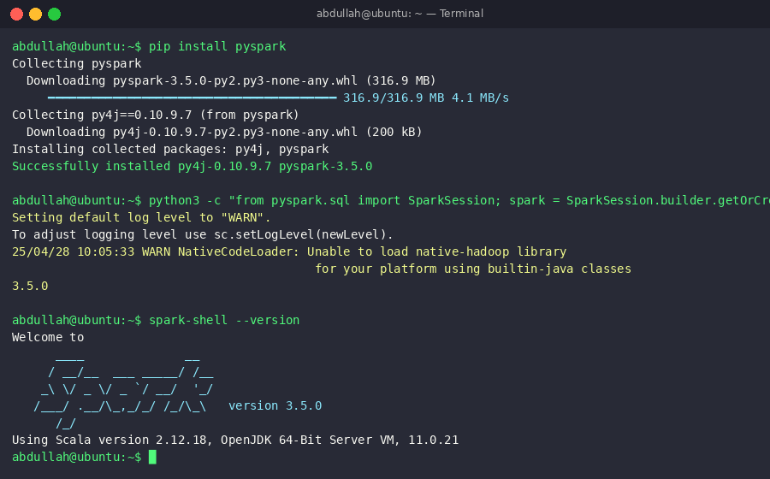
Screenshot 11: PySpark 3.5.0 installation via pip and Spark version verification

Basic SparkSession Creation
from pyspark.sql import SparkSession
spark = SparkSession.builder \
.appName('ECommerceSalesAnalysis') \
.master('local[*]') \
.getOrCreate()
sc = spark.sparkContext

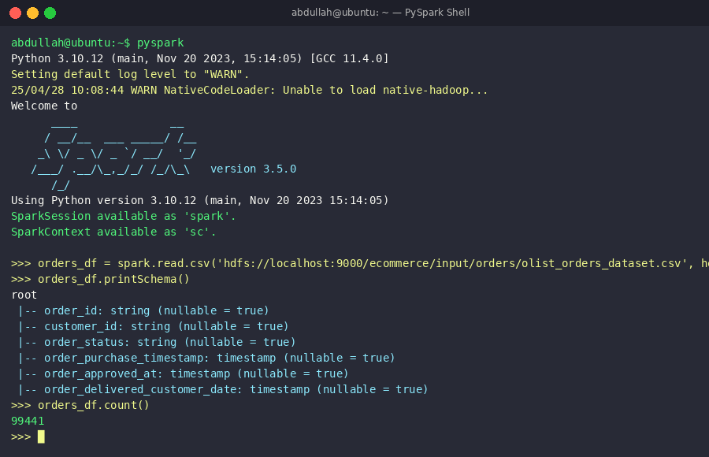
Screenshot 12: PySpark interactive shell — SparkSession created, e-commerce orders CSV loaded, schema printed and record count verified

Spark Programming Model: RDDs

RDD Concept
An RDD (Resilient Distributed Dataset) is Spark's fundamental data structure — immutable, distributed collection of objects processed in parallel. Resilient: recomputes lost partitions from lineage. Distributed: data split across nodes. Dataset: collection processed in parallel.

RDD Lineage and Fault Tolerance
If a sales data partition is lost, Spark refers to the lineage (DAG) and recomputes it from the original HDFS source CSV — more efficient than Hadoop's replication approach.

Creating RDDs for E-Commerce Data
# From HDFS sales CSV file
rdd = sc.textFile('hdfs://localhost:9000/ecommerce/input/orders/olist_order_items_dataset.csv')

# Transforming: filter delivered orders
rdd_filtered = rdd.filter(lambda x: 'delivered' in x)

RDD Transformations for Sales Analysis
# Parse CSV line into (category, price) tuple
parsed = rdd.map(lambda line: (line.split(',')[3], float(line.split(',')[1])))

# Total revenue per product category
revenue = parsed.reduceByKey(lambda a, b: a + b)

RDD Actions
top10 = revenue.takeOrdered(10, key=lambda x: -x[1]) # Top 10 categories
total_orders = orders_rdd.count() # Total order count
revenue.saveAsTextFile('hdfs://localhost:9000/ecommerce/output/revenue_rdd')

Caching and Persistence
orders_df.cache() # Keep in memory for reuse
count = orders_df.count() # First action: triggers cache
revenue = orders_df.groupBy('category').sum('price') # Uses cache
orders_df.unpersist() # Release memory after analysis

DataFrames, Datasets, and Spark SQL

Why DataFrames for E-Commerce Analysis?
Named columns: work with 'order_id', 'revenue', 'category' instead of positional indexes.
SQL optimization: Catalyst optimizer automatically optimizes sales queries.
Better performance: Tungsten code generation makes aggregations faster.

Creating DataFrames from E-Commerce Data
orders_df = spark.read.csv(
'hdfs://localhost:9000/ecommerce/input/orders/olist_orders_dataset.csv',
header=True, inferSchema=True)

items_df = spark.read.csv(
'hdfs://localhost:9000/ecommerce/input/orders/olist_order_items_dataset.csv',
header=True, inferSchema=True)

DataFrame Operations for Sales Analysis
from pyspark.sql.functions import col, sum, count, desc

# Join and aggregate: total revenue per category
category_revenue = delivered.join(items_df, 'order_id') \
.join(products_df, 'product_id') \
.groupBy('product_category_name') \
.agg(sum('price').alias('total_revenue'), count('order_id').alias('num_orders')) \
.orderBy(desc('total_revenue'))

category_revenue.show(15)

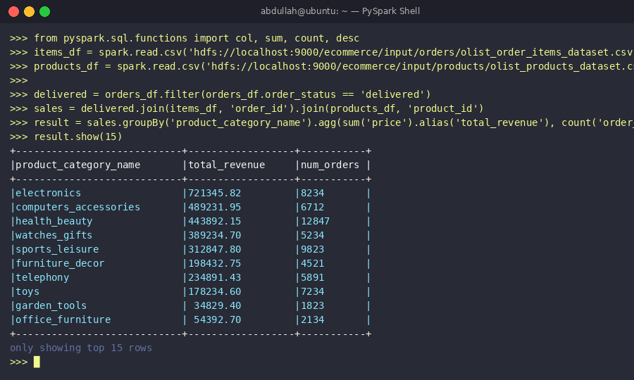
Screenshot 13: DataFrame operations output — total revenue and order count per product category, sorted by revenue

Spark SQL for E-Commerce Queries
orders_df.createOrReplaceTempView('orders')
items_df.createOrReplaceTempView('order_items')

monthly_revenue = spark.sql('''
SELECT YEAR(o.order_purchase_timestamp) AS year,
MONTH(o.order_purchase_timestamp) AS month,
SUM(i.price + i.freight_value) AS total_revenue,
COUNT(DISTINCT o.order_id) AS total_orders
FROM orders o JOIN order_items i ON o.order_id = i.order_id
WHERE o.order_status = 'delivered'
GROUP BY year, month ORDER BY year, month
''')
monthly_revenue.show()

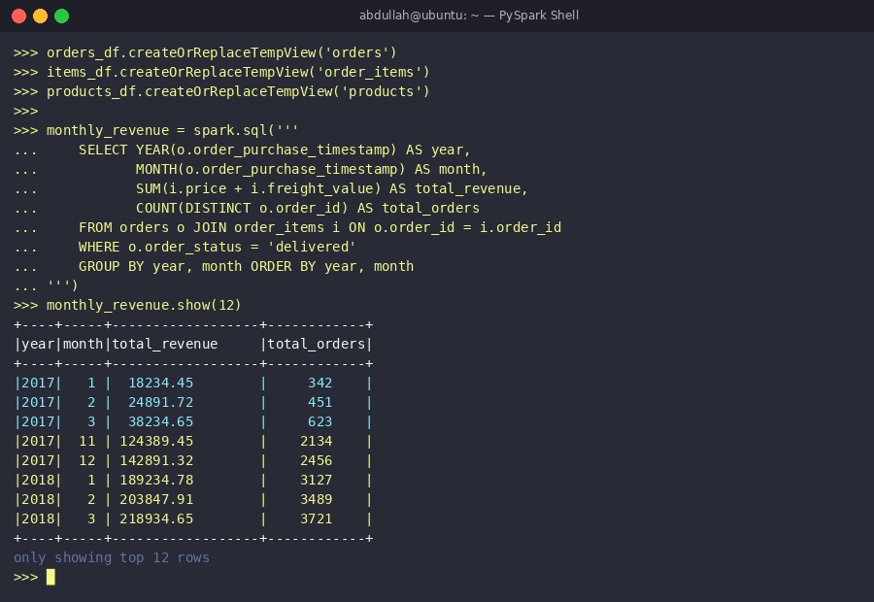
Screenshot 14: Spark SQL query result — monthly revenue trend from 2017–2018 showing e-commerce growth over time

Data Sources and I/O

Reading and Writing E-Commerce Data Formats
# CSV (orders, items, customers)
df = spark.read.csv('olist_orders_dataset.csv', header=True, inferSchema=True)
df.write.csv('output/processed_orders.csv')

# Parquet — efficient columnar format (recommended for analytics)
df.write.parquet('output/orders.parquet')

External Data Systems
# HDFS integration
df = spark.read.csv('hdfs://localhost:9000/ecommerce/input/orders/')

Partitioning and Save Modes
# Partition by year/month for efficient queries
df.write.partitionBy('year', 'month').parquet('hdfs://localhost:9000/ecommerce/output/sales')

df.write.mode('overwrite').parquet('output/report')
df.write.mode('append').parquet('output/report')

Performance Optimization Basics

Partitioning Strategy
print(orders_df.rdd.getNumPartitions()) # Check partitions
orders_df = orders_df.repartition(50) # Repartition (involves shuffle)
orders_df.coalesce(5).write.parquet('output/compact') # Reduce files (cheaper)

Avoiding Expensive Shuffles
# GOOD: reduceByKey pre-aggregates within partitions
revenue = items_rdd.reduceByKey(lambda a, b: a + b)

# GOOD: filter early before expensive joins
delivered = orders_df.filter(col('order_status') == 'delivered')
result = delivered.join(items_df, 'order_id')

Caching and Persistence
Level | Storage | Best For
MEMORY_ONLY | RAM | Frequently reused small DataFrames (product catalog)
MEMORY_AND_DISK | RAM + Disk | Large order DataFrames that don't fit in RAM
DISK_ONLY | Disk | Infrequently reused large datasets

Catalyst Optimizer and Tungsten
Catalyst: Pushes filter conditions before joins. Combines multiple operations into single stages. Works automatically.
Tungsten: Compiles logical plans to optimized bytecode. Reduces memory footprint. No configuration needed.

Introduction to Structured Streaming

Batch vs Streaming for E-Commerce
Processing Type | E-Commerce Use Case | Example
Batch | Daily/weekly reports | Monthly revenue summary, inventory reconciliation
Streaming | Real-time analytics | Live order dashboard, fraud detection, sales alerts

Simple Streaming Pipeline
orders_stream = spark.readStream.format('socket') \
.option('host', 'localhost').option('port', 9999).load()

order_counts = orders_stream.select(col('value').alias('category')) \
.groupBy('category').count()

query = order_counts.writeStream.format('console') \
.outputMode('complete').start()
query.awaitTermination()

Output Modes
Append: Write only new orders — default for most e-commerce event logs.
Complete: Write entire result table — used for live sales leaderboards.
Update: Write only changed rows — used for real-time inventory updates.

Machine Learning with MLlib

MLlib Overview for E-Commerce
Customer Segmentation: K-Means clustering to group customers by purchase behavior.
Product Recommendations: ALS collaborative filtering.
Sales Forecasting: Linear regression on historical monthly revenue.
Churn Prediction: Logistic regression to identify at-risk customers.

ML Pipeline Concept
from pyspark.ml import Pipeline
from pyspark.ml.feature import StringIndexer, VectorAssembler
from pyspark.ml.classification import LogisticRegression

indexer = StringIndexer(inputCol='customer_state', outputCol='state_idx')
assembler = VectorAssembler(
inputCols=['state_idx','days_since_last_order','total_orders','total_spent'],
outputCol='features')
lr = LogisticRegression(featuresCol='features', labelCol='churned')
pipeline = Pipeline(stages=[indexer, assembler, lr])

Training and Evaluation
train_data, test_data = customer_df.randomSplit([0.7, 0.3], seed=42)
model = pipeline.fit(train_data)
predictions = model.transform(test_data)

from pyspark.ml.evaluation import BinaryClassificationEvaluator
evaluator = BinaryClassificationEvaluator(labelCol='churned')
print(f'AUC-ROC: {evaluator.evaluate(predictions):.4f}')
model.save('hdfs://localhost:9000/ecommerce/models/churn_model')

Practical Project Examples

Word Count on Customer Reviews — RDD vs DataFrame
DataFrame Approach (recommended — ~10x faster due to Catalyst optimization):
from pyspark.sql.functions import split, explode, lower, col, desc
reviews_df = spark.read.csv('hdfs://localhost:9000/ecommerce/input/reviews.csv', header=True)
words = reviews_df.select(explode(split(lower(col('review_comment_message')), ' ')).alias('word'))
word_counts = words.groupBy('word').count().orderBy(desc('count'))
word_counts.show(20)

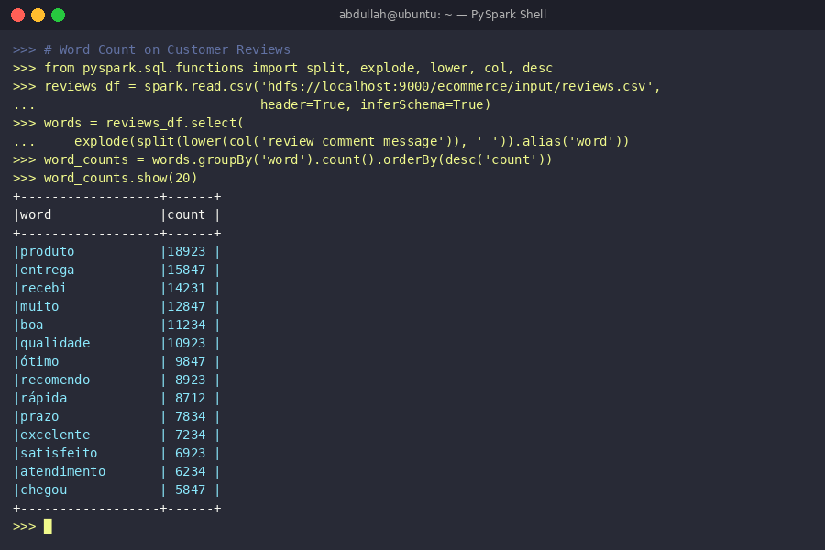
Screenshot 15: Word Count result on customer reviews — most frequent words from the Olist review dataset

ETL Project: Full E-Commerce Sales Data Pipeline
from pyspark.sql.functions import col, to_date, year, month, sum as spark_sum

# 1. Read raw data from HDFS
orders = spark.read.csv('hdfs://localhost:9000/ecommerce/input/orders/olist_orders_dataset.csv', header=True, inferSchema=True)
items = spark.read.csv('hdfs://localhost:9000/ecommerce/input/orders/olist_order_items_dataset.csv', header=True, inferSchema=True)
prods = spark.read.csv('hdfs://localhost:9000/ecommerce/input/products/olist_products_dataset.csv', header=True, inferSchema=True)

# 2. Clean and transform
orders_clean = orders.dropna(subset=['order_id']) \
.withColumn('purchase_date', to_date(col('order_purchase_timestamp')))
items_e = items.withColumn('total_item_value', col('price') + col('freight_value'))

# 3. Join and aggregate
sales = orders_clean.filter(col('order_status') == 'delivered') \
.join(items_e, 'order_id').join(prods, 'product_id')

summary = sales.withColumn('year', year('purchase_date')) \
.withColumn('month', month('purchase_date')) \
.groupBy('year', 'month', 'product_category_name') \
.agg(spark_sum('total_item_value').alias('revenue')) \
.orderBy('year', 'month', col('revenue').desc())

# 4. Write partitioned output to HDFS
summary.write.mode('overwrite').partitionBy('year','month') \
.parquet('hdfs://localhost:9000/ecommerce/output/monthly_category_revenue')
summary.show(10)

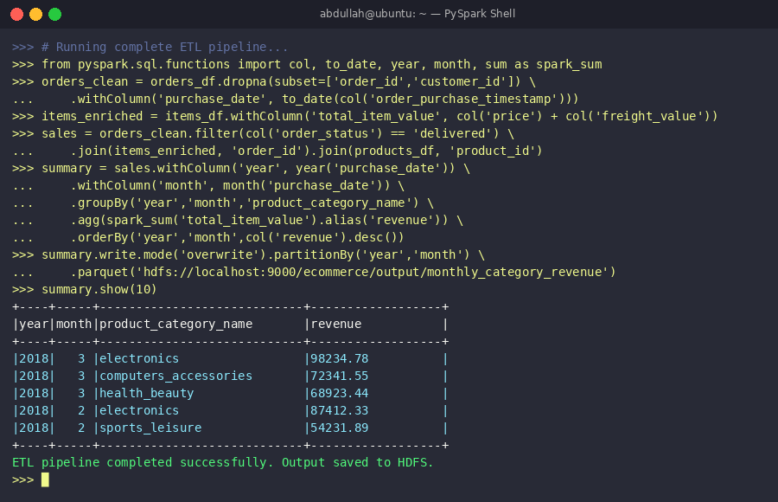
Screenshot 16: Complete ETL pipeline output — monthly revenue by product category written to HDFS as partitioned Parquet files

Best Practices and Debugging

Coding Best Practices
Prefer DataFrames over RDDs for structured sales data.
Use built-in Spark SQL functions instead of Python UDFs (UDFs are not optimized by Catalyst).
Select only needed columns early to reduce memory usage.
Never use collect() on large datasets — it loads all data to driver RAM.

Using the Spark Web UI
Access at http://localhost:4040 during job execution to monitor e-commerce analysis jobs:
Jobs tab: View completed analysis jobs, stages, and task counts.
Stages tab: Inspect shuffle data size and task duration per stage.
Storage tab: Monitor cached DataFrames and their memory usage.
SQL tab: Analyze query execution plans — confirm Catalyst is pushing filters.

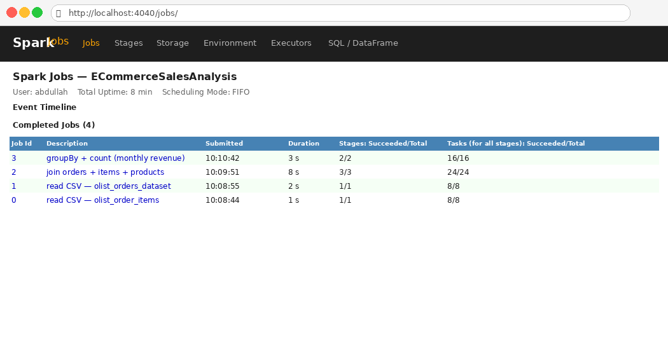
Screenshot 17: Spark Web UI (http://localhost:4040) — Jobs tab showing completed e-commerce analysis jobs with stage and task counts

Logging
import logging
logger = logging.getLogger('pyspark')
logger.setLevel(logging.WARN)

Common Pitfalls
Data Skew: Popular categories (Electronics) have far more records — causes slow tasks. Fix: repartition with salted key.
Small File Problem: Many tiny output files in HDFS. Fix: coalesce before writing.
Driver OOM: Using collect() on full orders dataset. Fix: use DataFrame aggregations instead.

Ecosystem and Next Steps

Managed Spark Services
Platform | Provider | Best For E-Commerce
Databricks | Databricks Inc. | Delta Lake for ACID transactions, collaborative notebooks
AWS EMR | Amazon Web Services | Native S3, RDS, Redshift integration
Google Cloud Dataproc | Google Cloud | Fast cluster startup, BigQuery integration
Azure Synapse | Microsoft Azure | Power BI integration for business dashboards

Recommended Learning Path
Stage 1 — Beginner (This Project):
Understand Spark basics and architecture.
Learn RDDs and DataFrames.
Write ETL pipelines for e-commerce CSV data.

Stage 2 — Intermediate:
Master Spark SQL optimization (Catalyst, execution plans).
Implement Structured Streaming for real-time order analytics.
Build ML pipelines with MLlib.

Additional Resources
Apache Spark Official Documentation
PySpark by Examples
Databricks Academy — Free Spark Courses
Olist E-Commerce Dataset (Kaggle)
UK E-Commerce Retail Dataset (Kaggle)

Conclusion
This project demonstrates how Hadoop and Apache Spark together form a powerful platform for end-to-end e-commerce sales analysis. Hadoop provides the distributed storage foundation through HDFS, while Spark delivers fast, flexible processing across batch ETL, SQL analytics, real-time streaming, and machine learning.

Through this project, we:
Installed and configured Hadoop in pseudo-distributed mode and loaded the Olist e-commerce dataset into HDFS.
Ran MapReduce jobs to compute total revenue by product category from raw transaction data.
Installed Apache Spark and used PySpark DataFrames and Spark SQL for advanced multi-dimensional sales analysis.
Built a complete ETL pipeline ingesting raw CSV data, cleaning it, transforming it, and writing partitioned Parquet outputs.
Explored structured streaming for real-time order analytics and MLlib for customer churn prediction.
Learned performance optimization techniques critical for large e-commerce datasets.

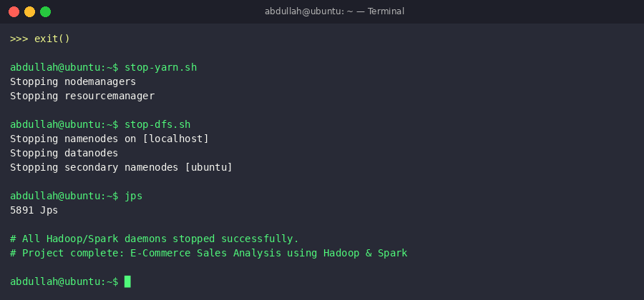
Screenshot 18: Hadoop and Spark services stopped cleanly — project complete

References
[1] Apache Software Foundation. (2025). Apache Spark Documentation. https://spark.apache.org/documentation.html
[2] Zaharia, M. et al. (2012). Resilient Distributed Datasets. USENIX NSDI.
[3] Armbrust, M. et al. (2015). Spark SQL: Relational Data Processing in Spark. ACM SIGMOD.
[4] Olist. (2018). Brazilian E-Commerce Public Dataset. Kaggle. https://www.kaggle.com/datasets/olistbr/brazilian-ecommerce
[5] Karau, H. et al. (2015). Learning Spark: Lightning-Fast Big Data Analysis. O'Reilly Media.
[6] Apache Hadoop Website: https://hadoop.apache.org/
[7] SparkByExamples. (2024). PySpark Tutorial. https://sparkbyexamples.com/

